Task 3:

Configure your base machine as “Yum Server.”

→ Copy all packages from DVD/ISO to base machine
→ share the packages via HTTP/FTP
1.Mounted bootable USB and installed vsftpd package using rpm.
2.Copy all packages to /var/FTP/centos.
3.Start FTP service. In the firewall, add FTP service.
4.Yum configured in /etc/yum.repos.d.centos.repo

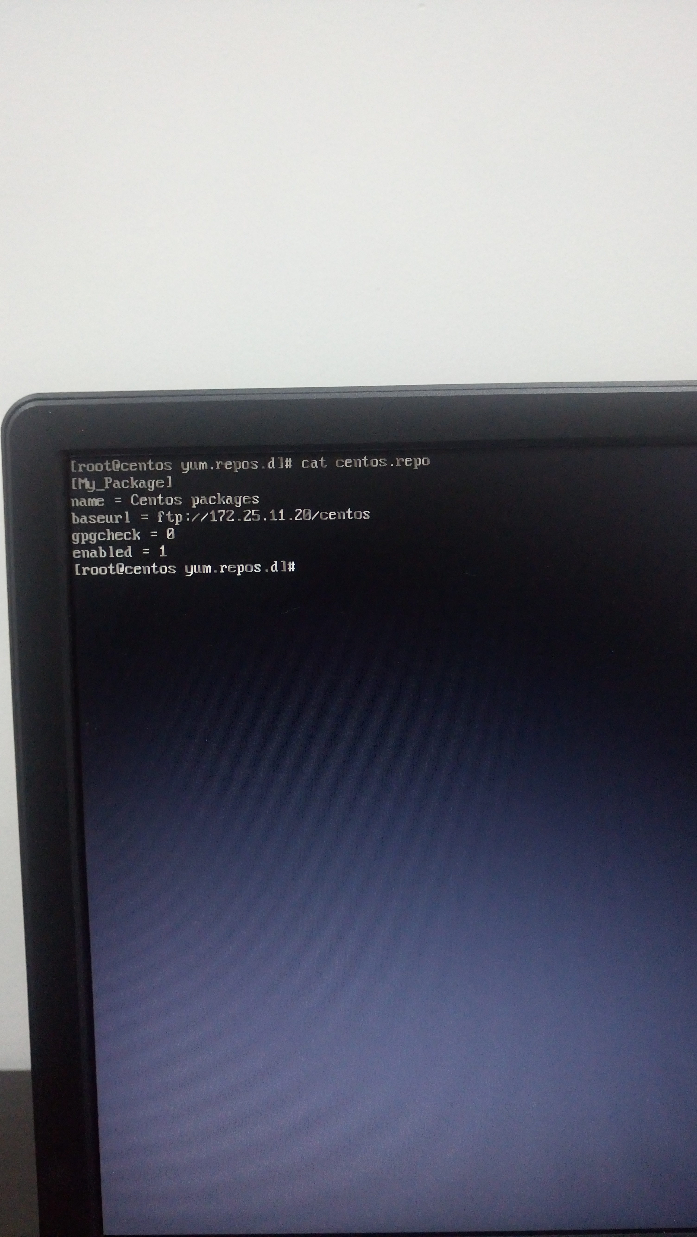

Task 4:

Install GNOME

1.GNOME installed as below
Command: yum, group install “GNOME Desktop.”

2. Set target as graphical
Command: systemctl set-default graphical Target

3.Reboot system

Task 5:

Install KVM / Virtual Machine Manager

1.To install KVM had installed the following packages.
command: yum install qemu-kvm libvirt libvirt-python libguestfs-tools virt-install virt-manager

2. Start and enable libvirtd service.

